AEP Networks Partner Programme – Product Specialisations
Grow your business in partnership with AEP
Dynamic, ambitious and fast moving, the security and communications market represents a huge opportunity - both for AEP Networks and for our partners.

About the Partner Programme
As customers requiring secure communications demand sophisticated solutions for their increasingly demanding business requirements, AEP Networks needs partners who can add value to our award winning certified range of security and communications products and services.
AEP Networks’ solutions give you the flexibility needed to deliver the end-to-end secure solutions and services your customers require to manage costs, increase productivity and stay ahead of the competition. So if you’d like to increase the value you offer to customers and grow your market share, in partnership with one of the world’s recognised leaders in secure communications solutions, this is your invitation to join AEP Networks as a Business Partner.

Partner Programme Benefits
By joining the AEP Networks Partner Programme you will enjoy a unique opportunity to work with us to offer a complete range of security and secure communications solutions, services and support for your customers.
The AEP Networks Partner Programme provides an accessible, flexible and straightforward framework for growing your revenues, increasing your expertise and differentiating yourself from your competitors.

Clear Partner Programme Objectives
The AEP Networks Partner Programme has a clear set of objectives to deliver a profitable relationship:
- Business made simple
The AEP Networks Partner Programme consists of simple guidelines and procedures to make doing business together as easy as possible without unnecessary bureaucracy.
- Fast sales and technical support
We recognise that we need to support you during your pre- and post-sales activities and so commit to helping you with your requests for sales and technical assistance.
- Increased discount opportunities
In addition to the standard discounts available for being an accredited partner, additional discount is available for becoming an accredited partner in multiple product disciplines.
- Regular focused communications
As an accredited partner you will be able to sign up for regular communications which will provide you with both commercial and technical help and advice to assist with your selling activities.
- Local market creation and support
Through market development funds (MDF) we will work with you to help create demand for your product specialisation in your local market. These activities could take the form of customer communications, webinars, seminars, tradeshows, public relations or other activities that you feel appropriate to promoting AEP’s solutions within your defined territory.
- A complete suite of sales tools to make selling easier
All authorized partners have access to the AEP Partner Portal which contains a comprehensive set of sales tools which will assist in assessing the market, qualifying customers, product evaluations, answering objections and closing sales.

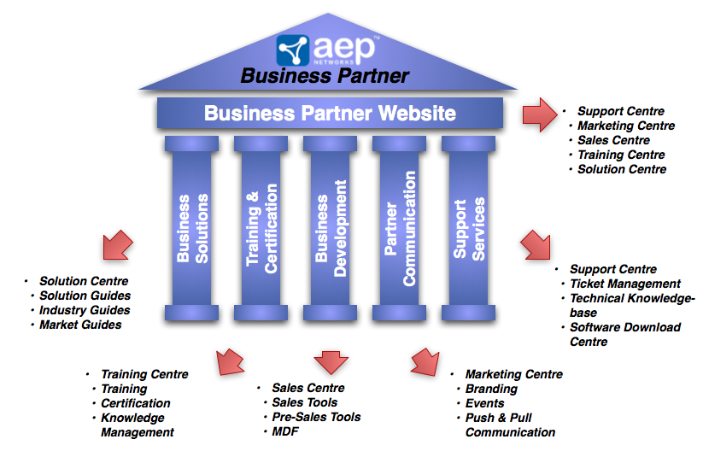

The Fast Track to Success
The AEP Networks Partner Programme is designed to make your organisation productive as quickly as possible without taking your sales and technical staff out of the field for long periods of time. You will build up a close, long-term relationship with AEP representatives who will help you create a pipeline of opportunities to help you build a profitable business.

Training for Success
In order to make your certified members of staff productive as quickly and efficiently as possible, we offer instructor-led sales and presales courses which will equip you with the necessary knowledge and tools to sell AEP’s Secure Communications Solutions. In addition, we have installation and maintenance courses which will provide your technical staff with the necessary knowledge to start offering additional services to your customers.

Sales Support – Helpdesk and Business Partner Website
We realise that in order to be successful at selling our solutions, we need to equip you with all of the necessary information and sales support. To do this, our sales help desk is available to all partners to provide assistance with sales and technical questions so that you can focus on progressing your opportunities. As an authorised partner you will also gain access to AEP’s dedicated partner portal which contains the most up-to-date market information, product and solutions literature and other sales tools.

Service Solutions
The structure of our service solutions means that you can initially offer your customers a full set of AEP-branded service offerings without having to build up your own capabilities. Once you experience growth in AEP product revenue you can expand your services capabilities to deliver more of them yourself and obtain larger discounts on support.
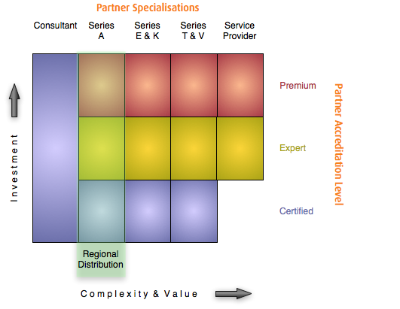

Product Specializations
To qualify as a partner in the AEP Networks Partner Programme at the Certified, Expert or Premium accreditation level, it is necessary for your organisation to become accredited in one or more product specialisations. These specialisations are designed to help partners use their existing expertise to build customer solutions based on AEP’s technology and products. Partners qualified in a particular product specialisation have proved that they have a good understanding of all of the commercial and technical aspects of the particular market segment and are fully prepared with the skills and knowledge necessary to give potential customers qualified advice on how AEP Networks’ solutions can meet their business requirements as well as how to support them after sale.
In order for a partner to become accredited in a particular specialisation, they must demonstrate that they have a certain number of sales, presales and support personnel (depending on the accreditation level) with the right knowledge and experience to represent AEP Networks in an effective and professional manner (see sidebar for details).
For a detailed description of the personnel requirements for each product specialisation, please see the separate “Product Specialisation Curriculum” document.
Partners must maintain a minimum number of sales, presales and support personnel based on their partner accreditation level and must keep up-to-date on all product developments by attending regular update sessions which will be delivered either online or face-to-face depending on the complexity of the content.

Personnel requirements
Sales personnel must be able to:
- Qualify the suitability of potential customers in order to assess their fit with AEP’s products
- Present the high level business benefits of deploying AEP products
- Respond to commercial objections
- Accurately quote a solution based on the AEP Product Specialisation
- Understand the high-level competitive landscape
Presales personnel must be able to:
- Qualify potential opportunities for a good technical fit
- Install, configure and demonstrate the product(s) associated with their product specialisation
- Understand the technical aspects of key competitors to the product(s) in with the product specialisation and be able to articulate AEP’s relative technical strengths.
Support personnel must be able to:
- Respond to all first line support calls
- Take detailed problem descriptions for escalation purposes
- Understand specific customer environments and how they relate to the deployment of AEP Networks’ products.

Multiple Product Specialisations
Partners are actively encouraged to hold accreditations in multiple product specialisations where appropriate to their business models and territories. Being accredited in multiple product specialisations will not only allow you to penetrate further into your customer base but it will also attract additional discounts across the products that you are accredited to. You do not have to hold the same accreditation level in each product specialisation to qualify for a greater discount across all of the products specialisations that you hold.

Series A
Users connecting to corporate applications from anywhere with any device (e.g. Home PCs, tablet devices) are a significant security and compliance risk for organisations. Series A allows you to offer your customers a proven solution to this ever-increasing challenge which provides a high level of security while giving end-users the flexibility they demand.
The high level of security is implemented through a combination of endpoint security management to ensure acceptable security standards of access devices and a broad range of standard user authentication options for integration with existing user identity schemes. In addition to high levels of security, usability and scalability are achieved through broad operating system support, universal printing to allow local printing as well as high availability and load balancing configuration options.
Ideal Series A product specialisation partners include:
- Citrix, VMware and MS Terminal Services specialists who want to provide a highly secure and easy to manage environment for their customers
- Application providers who want to provide secure local and/or remote access to critical business applications through a secure application access gateway
- Virtual Desktop Infrastructure (VDI) specialists who want to control access to individual applications

Partners who achieve the requirements of the Series A product specialisation are able to understand the need for secure application access solutions and are able to integrate them into customer networks in order to achieve both maximum security and end user productivity.
“Our help desk traffic is down 75%. There’s a tremendous saving in not having to visit each office, or troubleshoot each user’s PC. Users simply open their browsers and they have immediate access to a live database. This gives us significant cost savings.” Chris Granitz, Herbein + Company, Inc.
“Series A has met and exceeded our expectations for security and centrally managing all communications. The product was easy to install, is straightforward to manage and is very simple for our members to use.” Bryce Bowman, Medical Associates of the Lehigh Valley

Series E
Organisations are relying more than ever on network communications to conduct their business and have an increasing need to transmit confidential data securely over the Internet. Series E allows you to provide your customers with a high-grade IPSEC –based security solution that protects confidential communications without having to deploy expensive dedicated leased lines which are still not guaranteed to provide the level of security necessary. Series E also includes advanced central management which significantly reduces the time required for initial setup and on-going maintenance.
Series E encryptors are certified by the UK Government’s CESG Assisted Products Scheme (CAPS) to Enhanced Grade level, the Ministry of Defence Infosec Product Co-Operation Group. This means that you will be providing your customers with the most secure solution available on the market to meet their confidential transmission requirements.
Ideal Series E product specialisation partners include:
- Security resellers who want to add encryption to their portfolio
- Infrastructure providers deploying enterprise networks
- Those with existing relationships with government and enterprise accounts

Partners who achieve Series E product specialisation accreditation are able to understand the requirements of potential customers to securely transmit confidential data between corporate locations or from home-office to corporate offices. They also have the ability to design, deploy and manage these solutions in order to provide the most cost effective solutions for secure data transmission.

Series K
The Series K Hardware Security Module (HSM) is designed to generate, store and protect excellent quality cryptographic keys. As a Series K Partner you will be able to provide your customers with a high-grade solution allowing them to deploy secure and tamper-proof public key infrastructures (PKI).
This high level of security is based on a purpose-built HSM that, unlike other HSMs, is not exposed general-purpose operating systems vulnerabilities. It is also FIPS-140-2 level 4 certified which positively erases the keys if the hardware is tampered with.
Ideal Series K product specialisation partners are likely to:
- Already be providing integration into commercial solutions
- Have interest in providing public key infrastructures (PKI)
- Have relationships with organisations with requirements to protect digital assets or who want to establish trust between themselves and other organisations (e.g. content providers, domain name services organisations, online gaming companies)

Partners who achieve the requirements of the Series K product specialisation have the ability to recognise the need for a secure HSM solution with potential customer environments and also have the ability to specify and implement an appropriate solution to meet the customers’ key generation requirements.
((Side box))
“Security is a critical factor for ICANN’s DNSSEC deployment, so Keyper and FIPS Level 4 was an easy choice,”
– Richard Lamb, ICANN

Series V
Many organisations rely on a variety of bearer technologies (e.g. radio, satellite or terrestrial) to provide voice and data communication between remote and central sites. These links providing vital communication may be sub-optimal for the particular role as they may be:
- Legacy links (e.g. serial, X.25) that do not interface easily with modern IP networks
- Low speed links (e.g. GSM or satellite) due to the remote location
In these cases, it is necessary to deploy technology that can highly optimise communication to compensate for these sub-optimal conditions. By becoming a Series V product specialisation partner, you will be able to offer customers who rely on communication over a number of different bearers the ability to:
- convert legacy communications to IP for integration with modern networks
- consolidate multiple WAN connections into a single IP stream
- optimise voice traffic to allow toll-quality communications over low speed links
Series V partners will typically be:
- Defence contractors
- Systems Integrators
- Providing solutions to emergency services

Partners who achieve the necessary requirements of the Series V product specialisation can understand and deploy highly optimised solutions that allow organisations to streamline their infrastructures and maximise the available bandwidth available in order to provide reliable voice and data communications.

Service Provider
Service Providers recognise the need for security in their Hosted MSP and Cloud environments but deploying traditional security services involved making considerable up front investments. This CAPEX spending does not match their monthly subscription models.
AEP’s CloudProtect Security Solution is an innovative approach which mirrors current service provider revenue models and completely eliminates upfront CAPEX infrastructure costs using a ‘pay as you go’ subscription model. This means that service provider partners only pay for the service when it is used by their customers.
Service providers are now able to implement Application Security in a much more cost effective and risk adverse way thereby overcoming traditional barriers to market entry and service deployment, accelerating speed to market with immediate profitable recurring revenue streams.
Ideal Service Provider product specialisation partners are likely to be telcos, fixed and mobile network operators, Managed Service Providers (MSPs) and Cloud providers providing:
- Cloud application services
- Infrastructure as a Service (IaaS)
- Managed hosting services including Hosted virtual computing solutions
- Managed WAN services including managed data and voice IP services
- Enterprise Mobility and 3G data services
- Managed VPN services
- Multi-Bearer communications services

Next steps
((Same call to action as on the AEP Netwoks Partner Programme Summary))
