AEP Networks Partner Programme – Product Specialisations
Grow your business in partnership with AEP
Dynamic, ambitious and fast moving, the security and communications market represents a huge opportunity - both for AEP Networks and for our partners.

About the Partner Programme
As customers requiring secure communications demand sophisticated solutions for their increasingly demanding business requirements, AEP Networks needs partners who can add value to our award winning certified range of security and communications products and services.
AEP Networks’ solutions give you the flexibility needed to deliver the end-to-end secure solutions and services your customers require to manage costs and stay ahead of the competition. So if you’d like to increase the value you offer to customers and grow your market share, in partnership with one of the world’s recognised leaders in secure communications solutions, this is your invitation to join AEP Networks as a Business Partner.

Partner Programme Benefits
By joining the AEP Networks Partner Programme you will enjoy a unique opportunity to work with us to offer a complete range of security and secure communications solutions, services and support for your customers.
The AEP Networks Partner Programme provides an accessible, flexible and straightforward framework for growing your revenues, increasing your expertise and differentiating yourself from your competitors.

Clear Partner Programme Objectives
The AEP Networks Partner Programme has a clear set of objectives to deliver a profitable relationship:
- Business made simple
The AEP Networks Partner Programme consists of simple rules and procedures to make doing business together as easy as possible without the unnecessary bureaucracy of some partner programmes.
- Fast sales and technical support
We recognise that we need to support you during your pre- and post-sales activities and so commit to fast turnarounds to your requests for sales and technical assistance.
- Increased discount opportunities
In addition to the standard discounts available for being an accredited partner, additional discount is available for becoming an approved partner in multiple product disciplines.
- Regular focused communications
As an approved partner you will be able to sign up for regular communications which will provide you with both commercial and technical help and advice to assist with your selling activities.
- Local market creation and support
Through market development funds (MDF) we will work with you to help create demand for your product specialisation in your local market. These activities could take the form of customer communications, webinars, seminars, tradeshows, public relations or any other activities that you feel appropriate to promoting AEP’s solutions within your defined territory.
- A complete suite of sales tools to make selling easier
All authorized partners have access to the AEP Partner Portal which contains a comprehensive set of sales tools which will assist in assessing the market, qualifying customers, product evaluations, answering objections and closing sales.

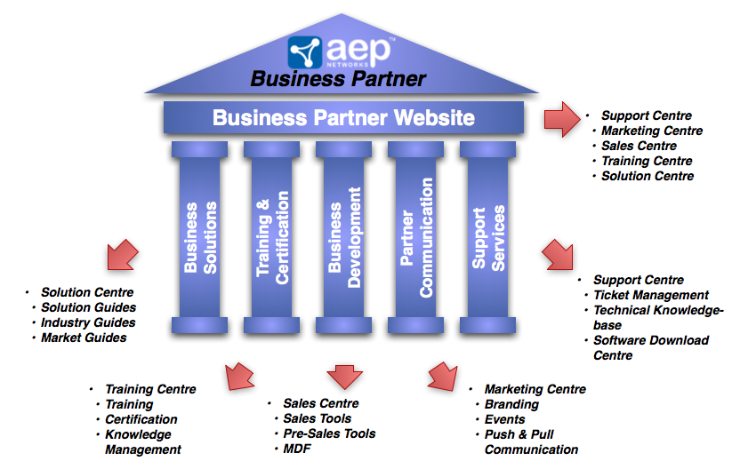

The Fast Track to Success
The AEP Networks Partner Programme is designed to make your organisation productive as quickly as possible without taking your sales and technical staff out of the field for long periods of time. You will build up a close relationship with AEP representatives who will help you create a pipeline of opportunities to help you build a profitable business.

Training for Success
In order to make your certified members of staff productive as quickly and efficiently as possible, we offer instructor-led sales and presales courses which will equip you with the necessary knowledge and tools to sell AEP’s Secure Communications Solutions. In addition, we have installation and maintenance courses which will provide your technical staff with the necessary knowledge to start offering additional services to your customers.

Sales Support – Helpdesk and Business Partner Website
We realise that in order to be successful at selling our solutions, we need to equip you with all of the necessary information and sales support. To do this, our sales help desk is available to all partners to provide assistance with sales and technical questions so that you can focus on progressing your opportunities. As an authorised partner you will also gain access to AEP’s dedicated partner portal which contains the most up-to-date market information, product and solutions literature and other sales tools.

Service Solutions
The structure of our service solutions means that you can initially offer your customers a full set of AEP-branded service offerings without having to build up your own capabilities. Once you experience growth in AEP product revenue you can expand your services capabilities to deliver more of them yourself and obtain larger discounts on support.
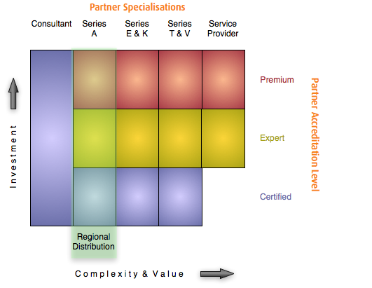

Product Specializations
To qualify as a partner in the AEP Networks Partner Programme at the Certified, Expert or Premium accreditation level, it is necessary for your organisation to become accredited in one or more product specialisations. These specialisations are designed to help partners use their existing expertise to build customer solutions based on AEP’s technology and products. Partners qualified in a particular product specialisation have proved that they have a good understanding of all of the commercial and technical aspects of the particular market segment and are fully prepared with the skills and knowledge necessary to give potential customers qualified advice on how AEP Networks’ solutions can meet their business requirements as well as how to support them after sale.
In order for a partner to become accredited in a particular specialisation, they must demonstrate that they have a certain number of sales, presales and support personnel (depending on the accreditation level) with the right knowledge and experience to represent AEP Networks in an effective and professional manner (see sidebar for details).
For a detailed description of the personnel requirements for each product specialisation, please see the separate “Product Specialisation Curriculum” document.
Partners must maintain a minimum number of sales, presales and support personnel based on their partner accreditation level and must keep up-to-date on all product developments by attending regular update sessions which will be delivered either online or face-to-face depending on the complexity of the content.

Personnel requirements
Sales personnel must be able to:
- Qualify the suitability of potential customers in order to assess their fit with AEP’s products
- Present the high level business benefits of deploying AEP products
- Respond to commercial objections
- Accurately quote a solution based on the AEP Product Specialisation
- Understand the high-level competitive landscape
Presales personnel must be able to:
- Qualify potential opportunities for a good technical fit
- Install, configure and demonstrate the product(s) associated with their product specialisation
- Understand the technical aspects of key competitors to the product(s) in with the product specialisation and be able to articulate AEP’s relative technical strengths.
Support personnel must be able to:
- Respond to all first line support calls
- Take detailed problem descriptions for escalation purposes
- Understand specific customer environments and how they relate to the deployment of AEP Networks’ products.

Multiple Product Specialisations
Partners are actively encouraged to hold accreditations in multiple product specialisations where appropriate to their business models and territories. Being accredited in multiple product specialisations will not only allow you to penetrate further into your customer base but it will also attract additional discounts across the products that you are accredited to. You do not have to hold the same accreditation level in each product specialisation to qualify for a greater discount across all of the products specialisations that you hold.

Series A
The Series A product specialisation recognises partners who demonstrate a commercial and technical understanding of deploying AEP’s secure application access solution.
The fact that users want to access corporate applications from anywhere on any device presents a significant security and compliance management challenge for the IT department. Rather than implement a draconian policy of banning all access from unapproved locations or devices, organisations need to be flexible in order to support the ever expanding business needs.
Series A provides you with the opportunity to offer your customers a solution to this ever-increasing challenge of needing to ensure that access to business-critical applications is secure and consistent even though their users may be constantly on the move with a wide range of uncontrolled devices (e.g home computers, tablet devices, etc). Series A products can also be used to ensure IT compliance by controlling and reporting on who in the organisation is accessing company applications and data.
The high level of security is implemented through a combination of:
- endpoint security management to ensure minimum security standards on access devices through “fingerprinting”, cache clean up and health checks
- a broad range of user authentication options so that the solution can be implemented in conjunction with existing user identity schemes.
In addition to high levels of security, usability and scalability are achieved through:
- broad operating system and application support to allow out-of-the-box operation
- universal printing to allow users to print locally
- high availability and load balancing options
Ideal partners for the Series A product specialisation include those who have experience in providing secure application access to customers or who have experience in deploying virtualisation technologies such as VMWare and Citrix.
Partners who achieve the requirements of the Series A product specialisation are able to understand the need for secure application access solutions and are able to integrate them into customer networks in order to achieve both maximum security and end user usability.
((Side box(es) with customer quotes to break up page – do we have permission to use the quotes publically?))
- “Our help desk traffic is down 75%. There’s a tremendous saving in not having to visit each office, or troubleshoot each user’s PC. Users simply open their browsers and they have immediate access to a live database. This gives us significant cost savings.” Chris Granitz, Herbein + Company, Inc.
- “Series A has met and exceeded our expectations for security and centrally managing all communications. The product was easy to install, is straightforward to manage and is very simple for our members to use.” Bryce Bowman, Medical Associates of the Lehigh Valley

Series E
The Series E product specialisation is an accreditation for partners who have the commercial understanding and technical ability to deploy AEP’s high security virtual private network (VPN) encryptors. This product allows you to deploy solutions for customers who have a requirement to securely transmit data between locations or who need to allow remote users to have access to confidential centralised resources over the Internet.
As organisations rely more and more on network communications to conduct their business, they increasingly have the requirement to transmit confidential data. Without the ability to strongly encrypt data, organisations have to install a dedicated leased line in order to do this. As well as being expensive, it was still not possible for the organisation to guarantee 100% that the data being transmitted was not being intercepted and read by a 3rd party. Today, most organisations are spread across many sites which it is not economically viable for them to deploy direct site-to-site communications.
By partnering with AEP as a Series E partner, you will be able to offer high-grade IPSEC-based security solutions that will give your customers to ability to transmit confidential traffic across the internet (either from site-to-site directly or from home offices to HQ) while being confident that their data will remain protected from being read in the event of any interception. In addition to providing high security VPNs, the Series E solution includes and advanced central management platform which will reduce the amount of work required by you and your customer during initial setup and on-going maintenance.
Series E encryptors are certified by the UK Government’s CESG Assisted Products Scheme (CAPS) to Enhanced Grade level, the Ministry of Defence Infosec Product Co-Operation Group. This means that you will be providing your customers with the most secure solution available on the market to meet their confidential transmission requirements.
As a Series E specialist, you will typically already work with customers in government and enterprise who have distributed sites and the requirement to transmit confidential data between sites.
Partners who achieve Series E product specialisation accreditation are able to understand the requirements of potential customers to securely transmit confidential data between corporate locations or from home-office to corporate offices. They also have the ability to design, deploy and manage these solutions in order to provide the most cost effective solutions for secure data transmission.

Series K
The Series K product specialisation recognises partners who demonstrate a commercial and technical understanding of deploying AEP’s Hardware Security Module (HSM) solutions. The HSMs allow you to deploy solutions for customers who need to deploy public key infrastructures (PKI) to set up a system to establish trust relationships between multiple parties.
AEP’s HSM is designed to generate, store and protect excellent quality cryptographic keys. Unlike many HSMs on the market, Series K supports high-security best practices when it comes to physical tampering or network attack. By becoming an AEP Series K Partner, you will be able to provide your customers a high-grade solution that will meet their needs regardless of how stringent their security requirements are. This high level of security is provided by:
- a purpose-build HSM that is not exposed to the typical vulnerabilities of general-purpose operating systems
- a system that is FIPS-140-2 level 4 certified which positively erases the keys if the hardware is tampered with.
Partners who should consider the Series K specialisation should have relationships with those organisations that have requirements to protect media assets or who want to establish trust relationships between themselves and other organisations or individuals. These include:
- Content providers (e.g. online music, software, media)
- Domain Name Services organisations that provide DNSSEC
- Registration, certification and validation authorities that issue, maintain and validate PKI identities and certificates
- Organisations providing eID and ePassports
- Online gaming companies.
Partners who achieve the requirements of the Series K product specialisation have the ability to recognise the need for a high-grade HSM solution with potential customer environments and also have the ability to specify and implement an appropriate solution to meet the customers’ key generation requirements.
((Side box(es) with customer quotes to break up page – do we have permission to use the quotes publically?))
“Security is a critical factor for ICANN’s DNSSEC deployment, so Keyper and FIPS Level 4 was an easy choice,”
– Richard Lamb, ICANN

Series V
Series V product specialisation allows you to offer your customers an advanced communication platform that aggregates both two-way voice and data over a wide variety of bearer (e.g. radio, satellite or terrestrial) to provide reliable and secure communications.
Many organisations rely on a variety of protocols and WAN technologies to provide communication between remote and central sites. These links providing vital communication may not be optimal to provide a high degree of confidence as they may be:
- Legacy communications links (e.g. X.25) that do not interface easily with modern IP networks
- Slower links (e.g. GSM or satellite) due to the remote location
In cases like this, it is necessary to deploy technology that can compensate for the lack of robustness of the actual links using other methods.
By becoming a Series V product specialisation partner, you will be able to offer customers who rely on communication over a number of different bearers the ability to:
- convert legacy communications to IP for integration with modern networks
- consolidate multiple WAN connections into a single IP stream
- optimise voice traffic to allow toll-quality communications even over narrowband connections
- get the most out of their existing bandwidth
Series V product specialisation partners work with companies with legacy communication infrastructures (e.g. banks) who want to consolidate multiple links over a single IP stream, transport organisations who use satellite communications to connect back to headquarters or to the internet (e.g. shipping companies and emergency services) and organisations that require quick deployment of reliable and secure communications in difficult-to-reach locations (e.g. armed forces and disaster recovery agencies).
Partners who achieve the necessary requirements of the Series V product specialisation can understand and deploy solutions that allow organisations to streamline their infrastructures and maximise the available bandwidth available in order to provide reliable voice and data communications.

Service Provider
Service Providers have long recognised the need for security in Hosted MSP and Cloud environments; this has been heightened by end-customer awareness of the issue in the light of increased media coverage. The traditional approach to deliver Secure Services in these environments has meant that service providers have had to make considerable up front investments in terms of security infrastructure procurement, licensing and support costs. This ‘build before service’ approach can severely impact a service provider’s financial performance due to its upfront CAPEX whilst customer revenues are realised on a monthly subscription basis. Latterly, some vendors have developed a halfway house by offering a deferred payment approach; this however does not change the impact of CAPEX investment versus OPEX revenues.
AEP Networks is taking a radical and innovative approach to this service provider dilemma with a commercial offering that mirrors current service provider revenue models and completely eliminates upfront CAPEX infrastructure costs. Based on a ‘pay as you go’ subscription model service providers can implement an AEP CloudProtect Security Solution, together with licensing, management and maintenance and only pay for it as and when their customers use it. The subscription is based on the number of secured concurrent connections for end-point clients.
AEP SECaaS ‘Security as a Service’ - The Disruptive Commercial Model for Service Providers
• The AEP CloudProtect solution can be scaled ON DEMAND as your customers request it
• Pay ONLY when your customers start using the service
• Pay your bills on a MONTHLY subscription basis
• NO contract term
• Increase service PROFITABILITY immediately with a new annuity revenue stream

Service providers are now able to implement Application Security in a much more cost effective and risk adverse way thereby overcoming traditional barriers to market entry and service deployment, accelerating speed to market with immediate profitable recurring revenue streams.
The AEP Service Partner Programme is available to Telcos, Fixed and Mobile Network Operators, Managed Service Providers (MSP) and Cloud providers who are involved in designing, building, implementing and managing services to end user organisations. These services take the form of billable services with service level agreements (SLAs) including
- Cloud application services
- Infrastructure as a Service (IaaS)
- Managed hosting services including Hosted virtual computing solutions
- Managed WAN services including managed data and voice IP services
- Enterprise Mobility and 3G data services
- Managed VPN services
- Multi-Bearer communications services

Next steps
((Same call to action as on the AEP Netwoks Partner Programme Summary))
